**SQL ASSIGNMENT-1**

**Create a database named "BooksDB" to store information about the bookstore's collection of books**

**Design a table called "Books" to store the details of each book, including the book's title, author, genre, publication year, and price.**

**Insert at least five books into the "Books" table, ensuring that each book has unique information for all columns.**

**PROGRAM**

**a. Retrieve all the books from the database.**

CREATE TABLE BOOKS(

BOOKS_TITLE VARCHAR(30),

AUTHOR VARCHAR(30),

GENRE VARCHAR(30),

YEAR INT,

PRICE INT

);

INSERT INTO BOOKS VALUES("ML","CHANDRA","SCI",1970,1000);

INSERT INTO BOOKS VALUES("DL","THARA","RESEARCH",1980,10000);

INSERT INTO BOOKS VALUES("MATHS","CHANDRA","THESIS",1990,5000);

INSERT INTO BOOKS VALUES("PROGLANG","NANDHINI","COMPSCI",2000,500);

INSERT INTO BOOKS VALUES("DS","SRI","SCI",2010,1500);

SELECT*FROM BOOKS;

**OUTPUT**

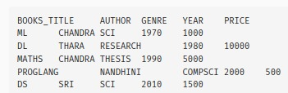

**b. Retrieve the details of a book based on its title.**

SELECT BOOKS_TITLE FROM BOOKS;

**OUTPUT**



**c. Update the price of a book.**

UPDATE BOOKS SET PRICE=8000 WHERE PRICE=5000;

SELECT*FROM BOOKS;

**OUTPUT**

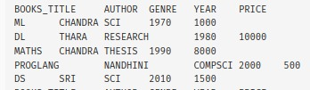

**d. Delete a book from the database based on its title.**

DELETE FROM BOOKS WHERE BOOKS_TITLE="PROGLANG";

SELECT*FROM BOOKS;

**OUTPUT**

